Experiment 1

Student Name: Lakshay Aggarwal UID: 25MCI10047
Branch: MCA (AI/ML) Section/Group: 25MAM-1(A)
Semester: 2-SEM Date of Performance: 07/01/2026
Subject Name: Technical Training - 1 Subject Code: 25CAP-652

- Aim of the Session:

To design and implement a sample database system using DDL, DML, and DCL commands, including database creation, data manipulation, schema modification, and role-based access control to ensure data integrity and secure, read-only access for authorized users.

- Objectives:

After completing this practical, the student will be able to:
- Understand the use of DDL commands to create and modify database structures.
- Perform DML operations such as INSERT, UPDATE, DELETE, and SELECT.
- Implement relationships using primary and foreign keys.
- Apply DCL commands to manage roles and privileges.
- Analyze input and output of SQL queries in a real database environment.

- Practical / Experiment steps:
  - Design the database schema for Department, Employee, and Project tables.
  - Create tables using appropriate constraints.
  - Insert sample records into tables.
  - Perform update and delete operations.
  - Retrieve data using SELECT queries.
  - Create a role and grant/revoke privileges.
  - Alter and drop database objects.

- Procedure of the Experiment:
- Start the system and log in to the computer.
- Open PostgreSQL software.
- Create database exp1.
- Create tables using DDL commands.

Create table Department

create table Department

(

Deptid int PRIMARY KEY,

Deptname varchar(20) NOT NULL UNIQUE

);

Create table Employee

CREATE TABLE Employee (

Empid int PRIMARY KEY,

Empname varchar(20) NOT NULL,

Empemail varchar(30) UNIQUE NOT NULL,

Empphone varchar(10) UNIQUE NOT NULL,

Deptid int,

FOREIGN KEY (Deptid) REFERENCES Department(Deptid)

);

Create table Project

CREATE TABLE Project

(

Projid int PRIMARY KEY,

Projname varchar(40) NOT NULL,

ProjstartDate date NOT NULL,

ProjendDate date NOT NULL,

ProjAssignEmp int,

FOREIGN KEY (ProjAssignEmp) REFERENCES Employee(Empid)

);
- Insert records using DML commands

Insert into Department

insert into Department (Deptid, Deptname) values

(1,'Marketing'),(2,'Finance'),(3,'IT'),(4,'HR');

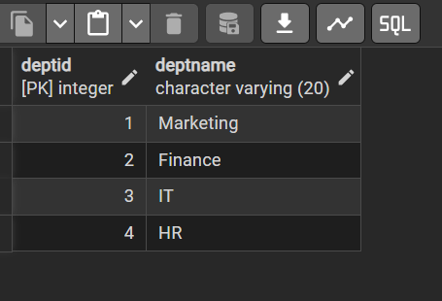

Insert into Employee

insert into Employee(Empid, Empname, Empemail, Empphone, Deptid) values

(101,'Lakshay','Lakshay@gamil.com',9465550343,1),

(102,'Neha','NehaAgg@gamil.com',6284511540,2),

(103,'Saneha','Saneha@gamil.com',1234567891,3),

(104,'Priya','Priya@gamil.com',9876543210,4),

(105,'Tushar','Tushar@gamil.com',7986015080,1);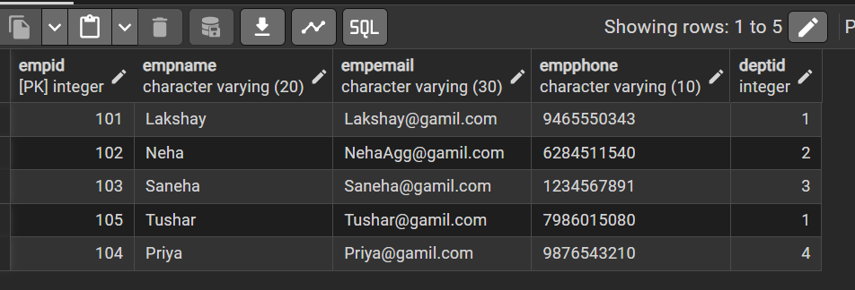

Insert into Project
insert into Project(Projid, Projname, ProjstartDate, ProjendDate, ProjAssignEmp)values
(501,'Festive Promotion Campaign','2026-01-01','2026-01-31',105),
(502,'Payout Maintainence','2026-01-28','2026-01-31',104),
(503,'ERP Development','2026-01-01','2026-01-15',103),
(504,'Tax Auditng for month','2026-01-20','2026-01-29',102),
(505,'Market Funnet Analysis','2026-01-21','2026-01-30',101),

(506,'Brand Perception Analysis','2026-01-01','2026-01-31',101);
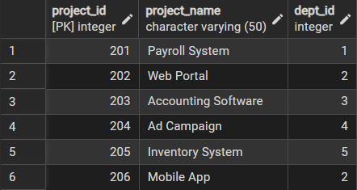

- Update and delete records

UPDATE Employee

SET Empphone = 9999888800

WHERE Empid = 104;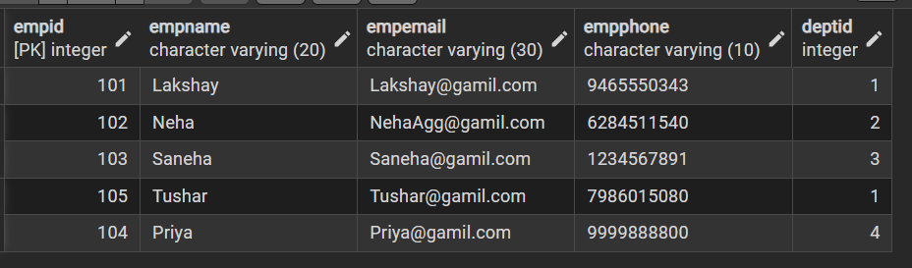

DELETE FROM Project

WHERE ProjAssignEmp = 104;
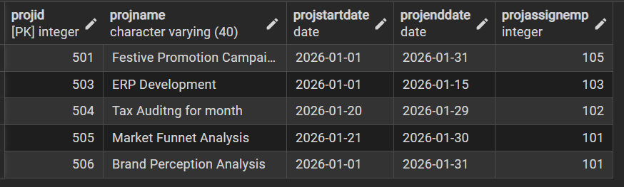

- Create role and assign privileges.

CREATE ROLE Auditor LOGIN PASSWORD 'Audit@2020';



GRANT SELECT ON Department, Employee, Project TO Auditor;

REVOKE SELECT ON Project FROM Auditor;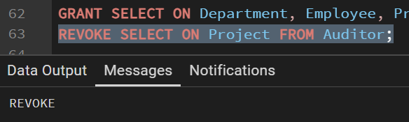

- Learning Outcomes (What I have learned):
- Create database tables using DDL commands with appropriate constraints to ensure data integrity.
- Perform DML operations such as INSERT, UPDATE, and DELETE on database records.
- Establish relationships between tables using PRIMARY KEY and FOREIGN KEY constraints.
- Implement role-based access control using DCL commands to provide secure, read-only access.
- Modify and manage database schemas using ALTER TABLE and DROP TABLE commands.

